United States Announces $92 Million in Additional Humanitarian Assistance for Nigeria
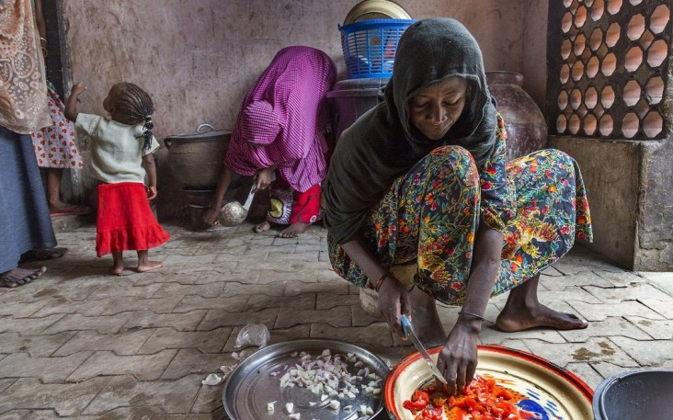
USAID/Office of U.S. Foreign Disaster Assistance
The United States announced today nearly $92 million in additional humanitarian assistance to people affected by the ongoing conflict and severe food insecurity in Nigeria and throughout the Lake Chad Basin region.
With this announcement, the United States is providing more than $291 million in humanitarian assistance since the 2016 fiscal year to people affected by the Boko Haram-related conflict and the related humanitarian crisis. The United States continues to be the single largest humanitarian donor to the region.
This new funding to United Nations and NGO partners will help tens of thousands of people receive critically needed humanitarian assistance, including food, water, shelter, and services to address acute hygiene, protection, and nutritional needs.
In Nigeria, Niger, Cameroon and Chad, the conflict has left more than 6.4 million people in need emergency food assistance and displaced 2.6 million people. The United Nations estimates an additional $1 billion is needed to meet the humanitarian needs of people in 2017. The United States calls on other donors to contribute additional humanitarian assistance for the millions of people in the region whose lives have been affected by Boko Haram violence

